Testing facilities for Avlino housekeeping

Date: Oct 21, 2024
By: Ron de Waard

Contents
Testing facilities for Avlino housekeeping 1
Prerequisites for test execution 2
Preparation for and executing a testrun 2
Step 1: using jmeter 3
Step 2: run the blockmap sql-query 5
Step 3: Start the housekeeping job in the aicon webapp. 8
Step 4: Copy the generated moves into he blockmap. 10
How to analyze a housekeeping plan? 12
The [blockmap] tab 12
Reporting and validation 16

To speed up testing we provide some scripts and analysis tools. We have the following available:
- Jmeter script to generate n delivery appointments for given day and block
- Excel analysis tool to assess the quality of an Aicon plan (blockmap xlsx).

Prerequisites for test execution
We expect the following to be available for a test user:
- Access to the Navis test environment (e.g. T2)
- An installed jmeter instance in that environment including the scripts needed
- Access to the database belonging to that environment
- Access to the Aicon webapp

Preparation for and executing a testrun
In preparation of a landside housekeeping testrun the following needs to be done first, in the following order
- Create n appointments within the horizon period for desired block using the jmeter script
- Run the db-query to get the current block state (== all container positions with relevant properties incl. appointment times and outstanding work instructions). The SQl query can be found in the blockmap excel.
- Start the job in the aicon webapp
- Once a job has been created, download the moves and copy them into the blockmap.

Step 1: using jmeter
On the desktop of rwgacceptance you double-click on the jmeter-shortcut, which starts jmeter. Once started select the script
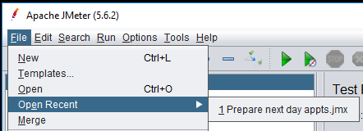
Typically this can be found in the Open Recent menu-item, otherwise choose the OIpen and select it from the testplans folder of the AVLINO Share folder.
Initially the script shows the Variables form:
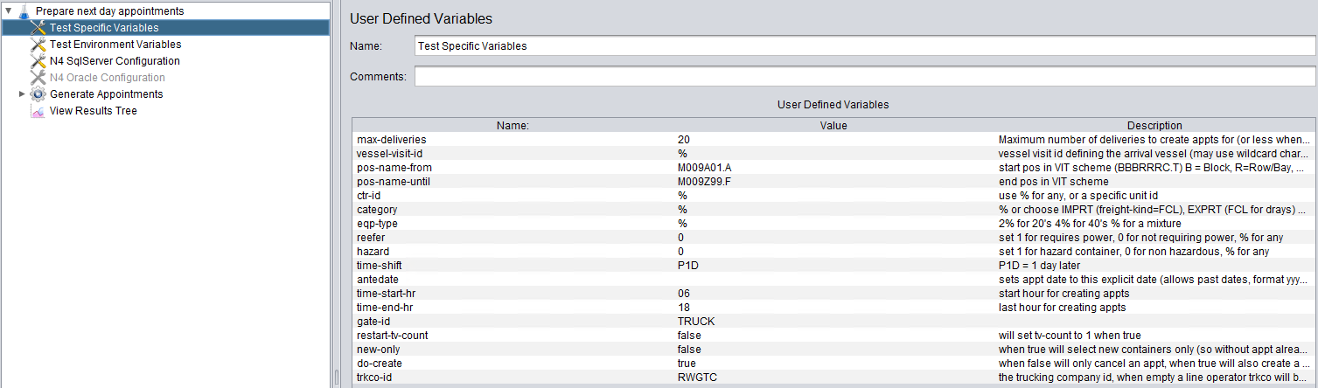
The description should explain the purpose of a variable, some of them are frequently used:
- Max-deliveries; select the maximum number of deliveries to create an appointment for; the script will select n number of containers based on the other variables. This value maximizes the number of containers, but it may happen that less or even 0 containers are found, then you have to change some of the search variables.
- Pos-name-from/until; typically you use this to change the block-id in both variables only, but sometimes you want to create appointments only for containers in a specific area of the block.
- Time-shift; this will define the day of the appointments to be created, P1D means the next day, P0D means today. P1D is standard.
- Time-start-hr/end-hr; these 2 variables defines the time period in which appointments will be created and it is done randomly.
- Restart-tv-count; when true the generated truck license will start with 1 again, otherwise it will continue using the last truck license sequence +1 for successive runs.
- New-only; every run will randomly pick import containers (with given search variables) without checking if they already have an appointment for given period. Sometimes you want to avoid that, by setting this to true.
- Do-create; will create an appointment when true, otherwise it will only cancel an existing appointment for the found container-id. The testscript is re-entrant, meaning you can run the script over and over again, because for each chosen container it will first clear everything before it creates a new one again.
Running the script is easy, click on the green play button. The result of the run can be followed using the View Results Tree:
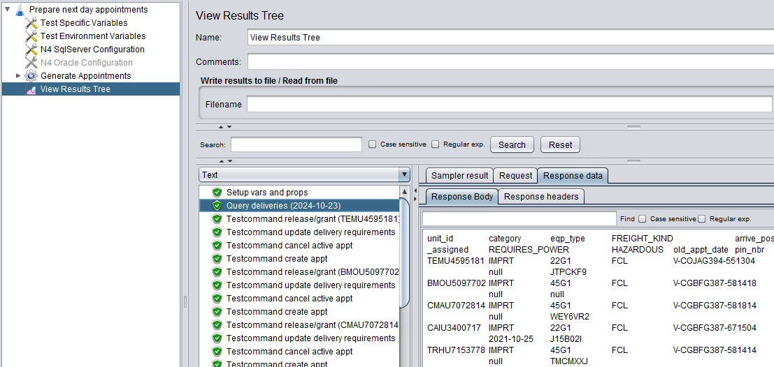
If you click on Query Deliveries test step, select Response Data you can see all found containers meeting the variables for which appointments are cancelled and created.
On every test step you can view the request and response; when there is an error you can see what has been reported in the response for instance.
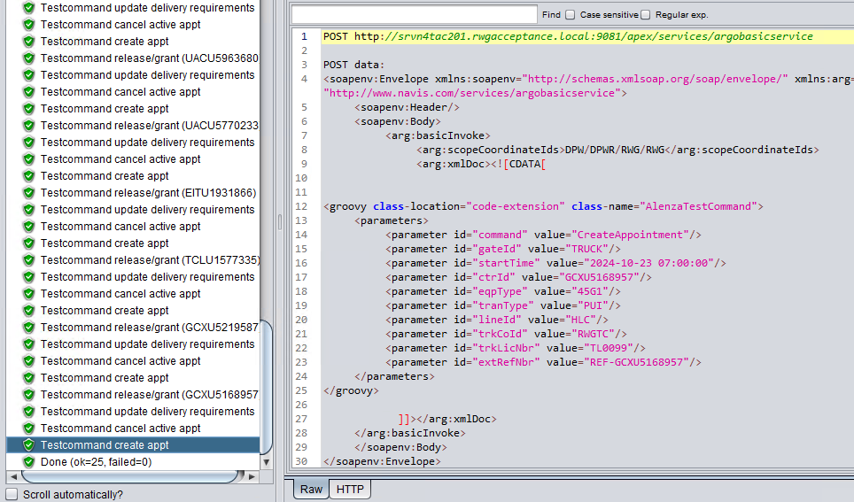
The last line shows the number of failed/successful created appointments.

Step 2: run the blockmap sql-query
The query can be found in the blockmap excel tab [site-settings], see the blue marking:
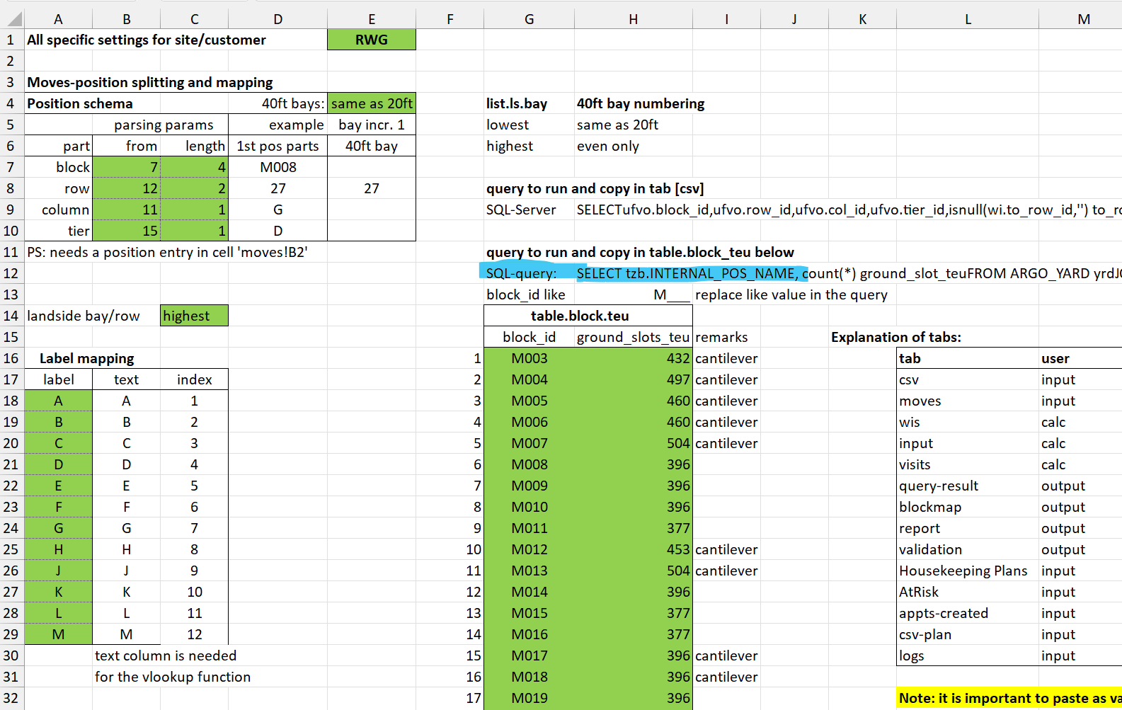
This tab also contains all site-specific settings for RWG.
In preparation for storing the result of the query I suggest to create a new copy of the excel using the following naming convention (but that is up to you):
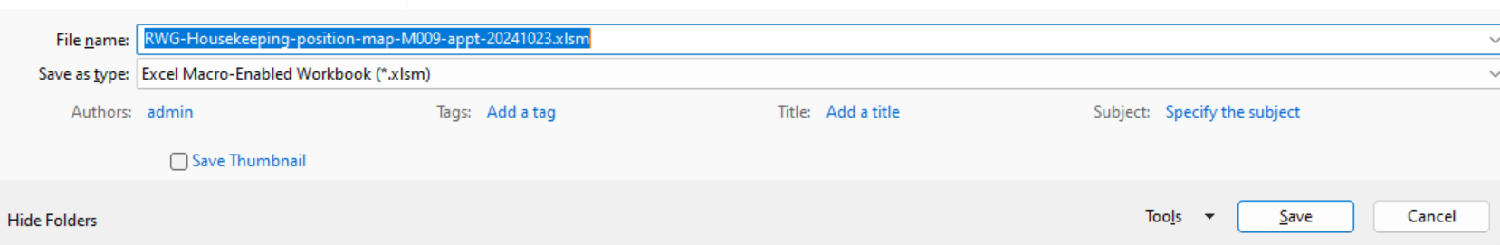
So I add the block-id and the date of capturing the blockmap (today is Oct 23rd).
Once you have a fresh copy, you have to wipe the content of the [csv] tab in the blockmap excel, to avoid old data still being present in your blockmap.
Go to cell A1 in tab [csv] and press twice [Ctrl]-[A]; this will select all data inside this tab. Then press [Delete].
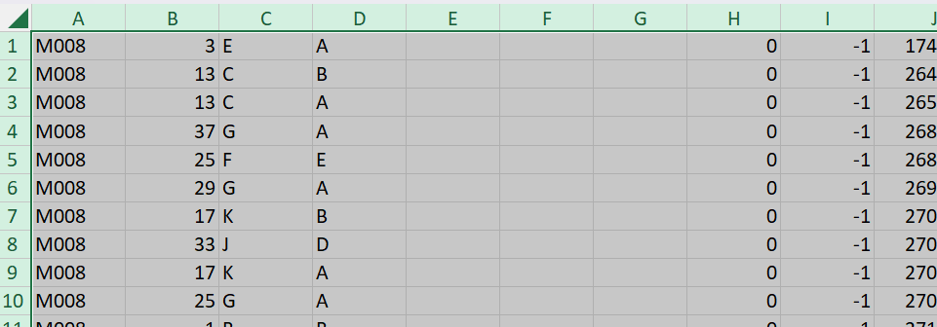
And go back to cell A1.
Next, start the SQL Server Management Studio app in rwgacceptance:
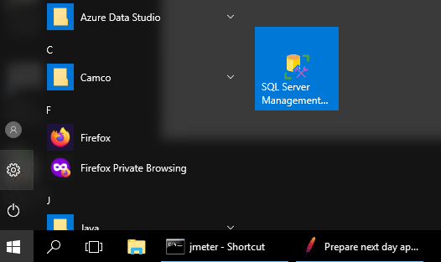
And login using your Windows credentials.

The query should also be available as a .sql script file in the Sql Server app. Once your logged in, type [Ctrl]-[O] (== menu File/Open/File…) and select the hk-blockmap.sql:
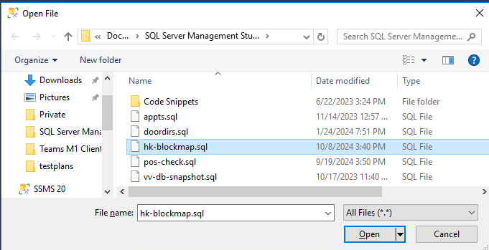
When used once this file can also be found using File/Recent Files.
The script contains multiple query. When you click the Execute button it will execute all queries found in the script file, something you typically do not want. To only Execute the deried query, select the whole query in the editor and then press Execute.
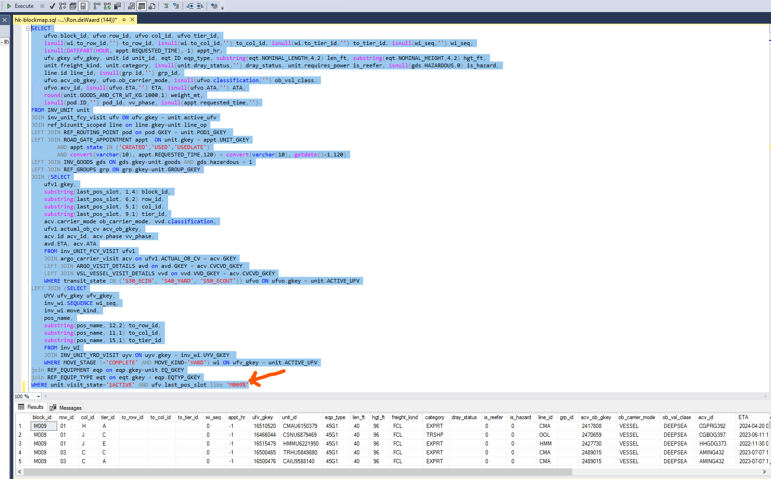
At the orange arrow at the bottom you can change the block to run this query for. Currently the example is for M009. To copy the result of the query, click on 1 of the output rows, click [Ctrl]-[A] followed by [Ctrl]-[C].
Go back to the blockmap excel, tab [csv] and paste [Ctrl]-[V] the results starting in cell A1, resulting in:
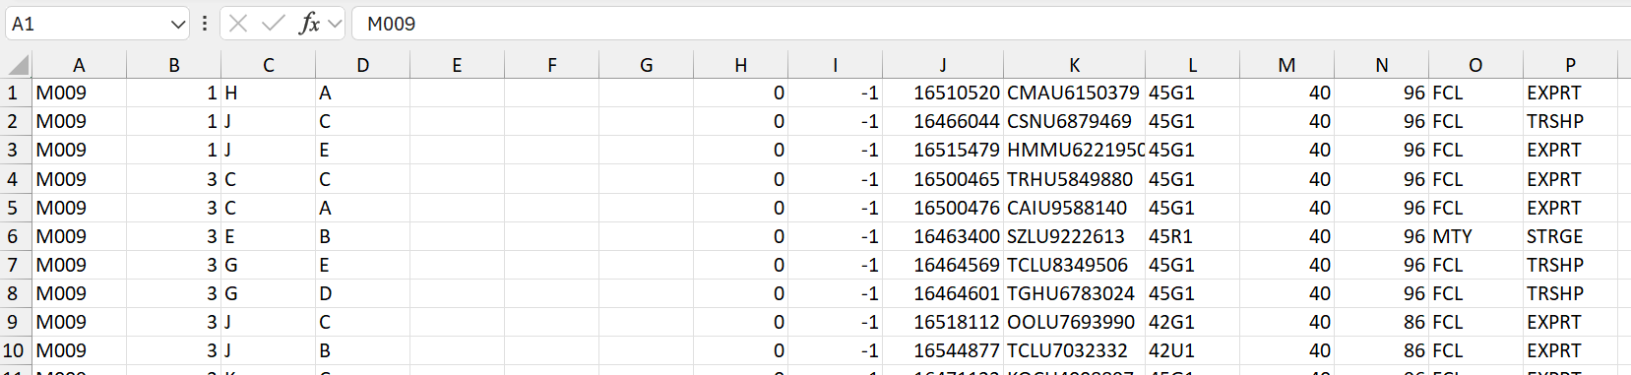
Before we can show the current state of the block, a bit more clean up (if needed) needs to be done). Go to the [moves] tab and check if there are any data rows. If so delete everything starting at row 2.
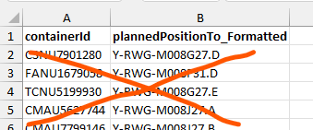
So now we have the current state of the block captured. You can do some checks using the following tabs of interest: blockmap, report and validation (they will be explained later).

Step 3: Start the housekeeping job in the aicon webapp.
Login to the Aicon webapp attached to the same RWG environment and go to the Job Services menu item.
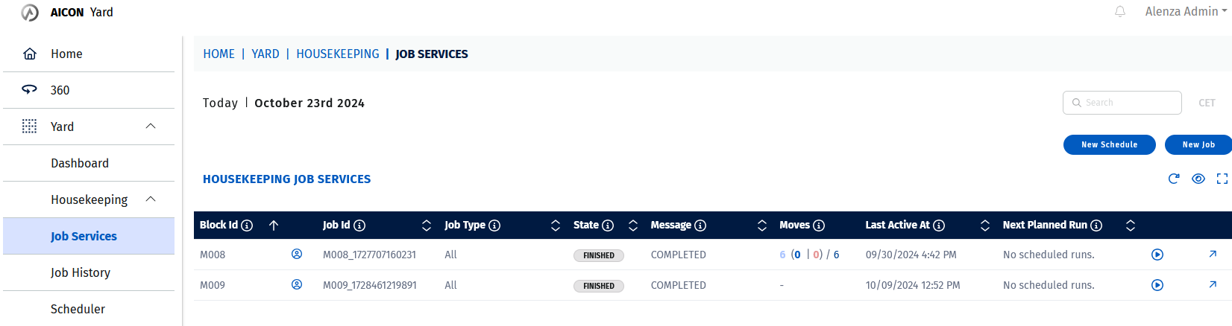
Click on New Job to create a new housekeeping job.
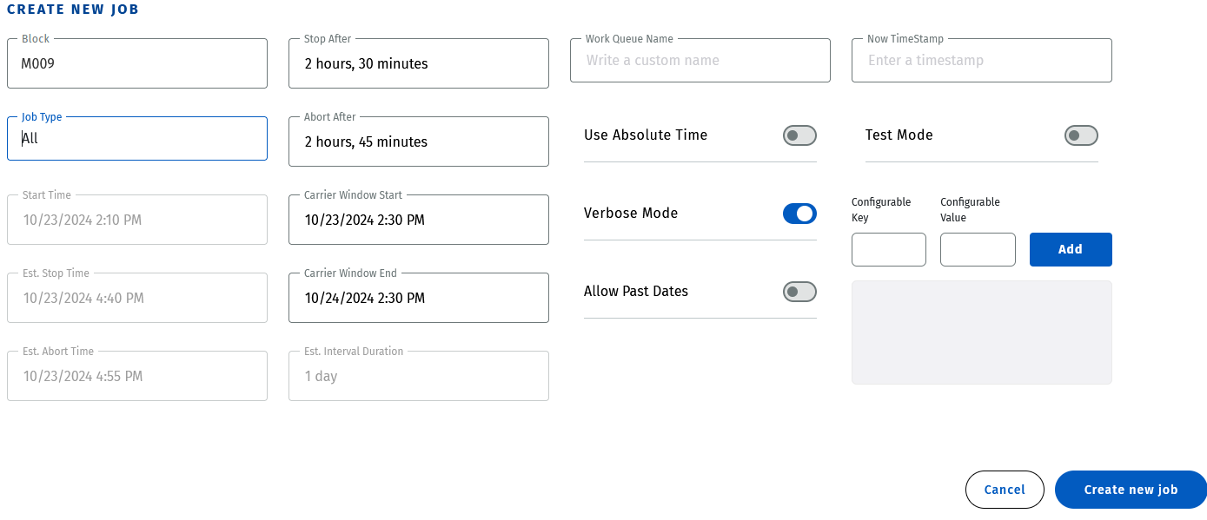
Relevant fields for creating a job are:
- Block; obvious value
- Job Type; All or Landside/Waterside only
- Stop After; run time of the job, up to 24 hours, for this test we think 2,5 hrs should be enough (a job can always be stopped earlier if needed).
- Abort After; this is typically set 15 minutes later than the stop. Stop means, “don’t send any more moves”, Abort means “we are going to delete any outstanding moves”;
- Work Queue Name; when you want to overrule the default configure done
Especially for testing, we can set this to a special test mode. This page shows an extra testing column on the right, allowing to set a different timestamp to test busy/quiet hours. To use this switch to Test Mode and fill in Now Timestamp like ‘2024-10-23T20:00:00+02:00’ to run the job as if it was started at 20:00 this evening local time.
Once done press the [Create new job] button and wait a few minutes to allow the housekeeping planner to generate a plan.

The webapp returns to the jobs overview, showing that the job has been activated:
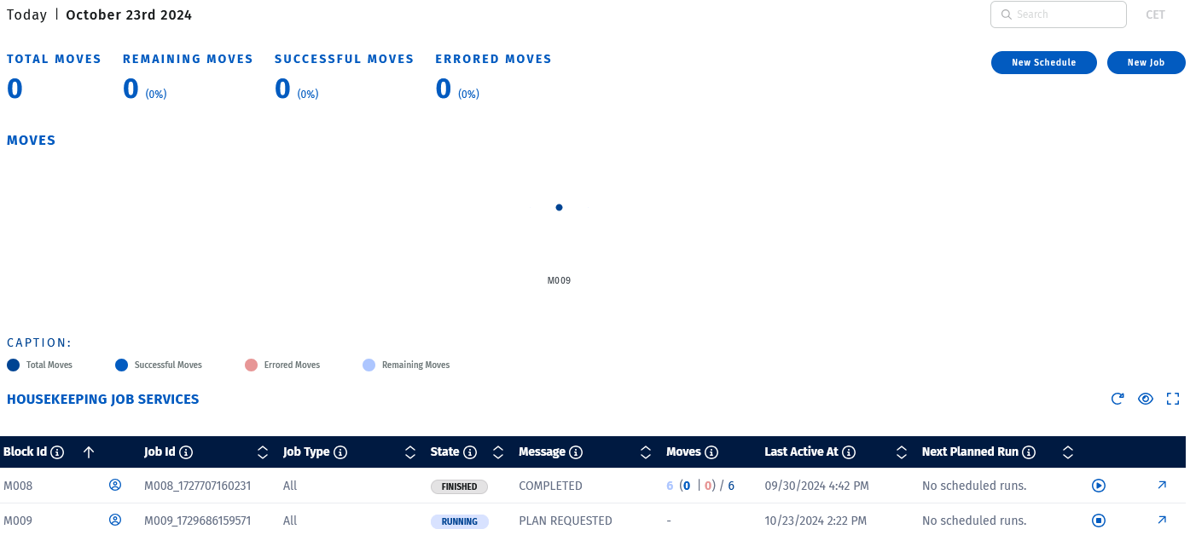
Click on the job to get an overview of the moves:
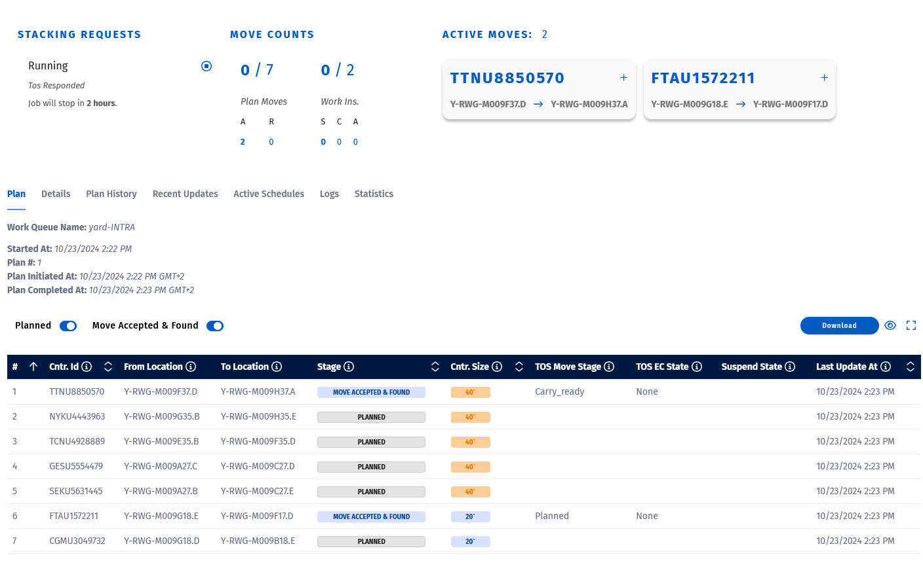
Click the download button and save the excel sheet. This will contain the information of the moves generated by the plan and we will feed it into the blockmap as follows:
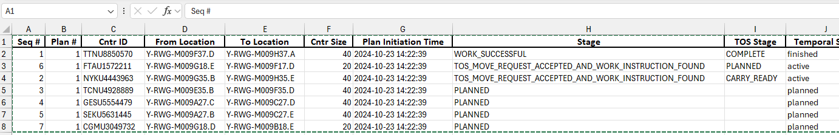
Use [Ctrl]-[A] [Ctrl]-[C] to select all and copy all data from the download.

Step 4: Copy the generated moves into he blockmap.
Go to the blockmap excel, and to the tab with the same name [Housekeeping Plans], clear all content and use Paste as Values starting from cell A1. So this should copy all data into the blockmap.
Last step is to select the values for Cntr Id and To Location (use the [Ctrl] key to select the 2 separate value list) and press [Ctrl]-[C]:
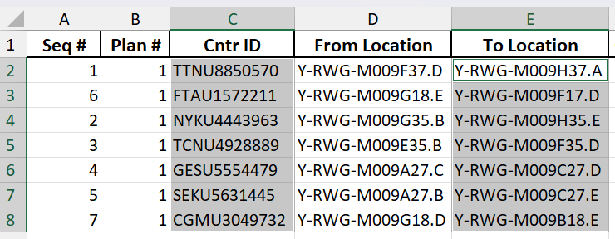

Now go to the [moves] tab and paste them here:
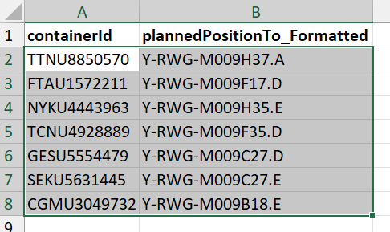
Now we are set to see the current state plus our plan in one view into the [blockmap] tab.
The reason for this separate copy/paste action is that many plans are being generated over time and you have to decide for yourself which part of the plan you want to analyze. Of course all Completed moves always needs to be part of the [moves] list, but which iteration with future moves you want to choose is up to you. The download will always shows all completed and active Work Instructions and the planned moves of the current iteration.

Other interesting pages of the job are:
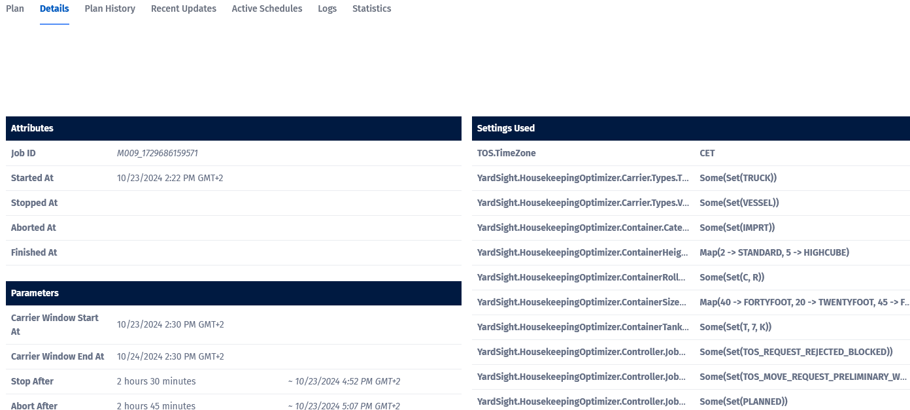

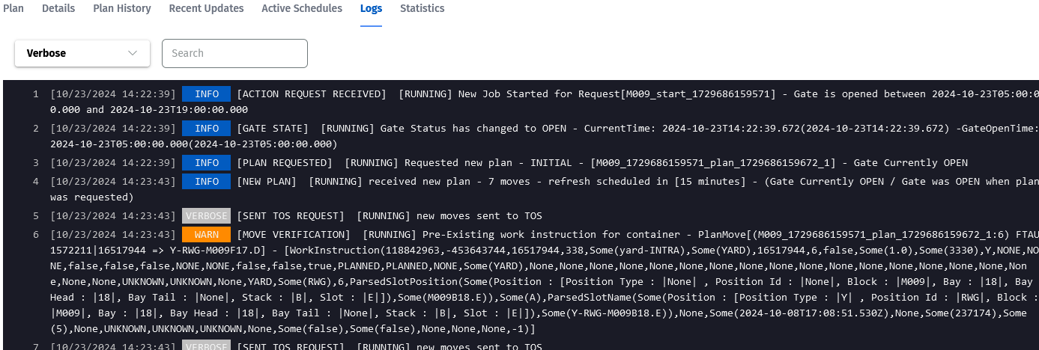
Shows progress of the job creation and also warnings and errors raised.
Progress will also shown in the moves like:

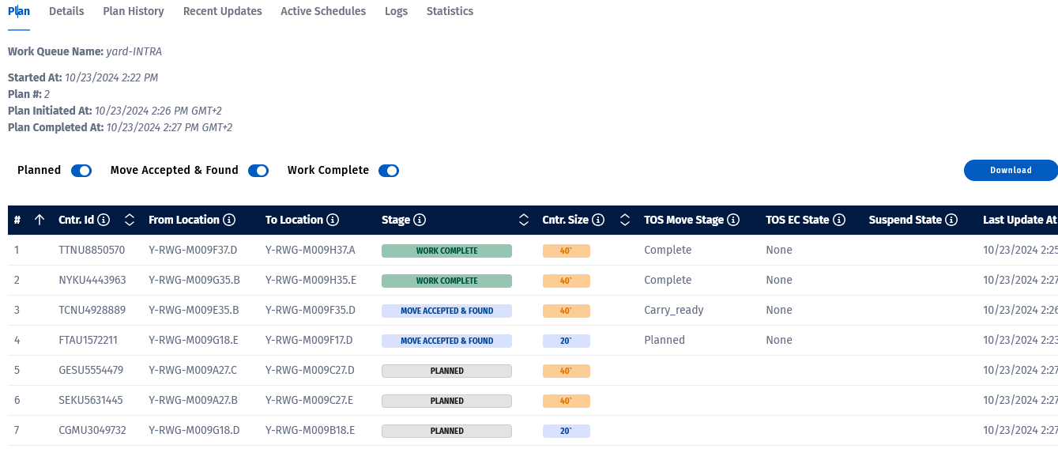

How to analyze a housekeeping plan?

The [blockmap] tab
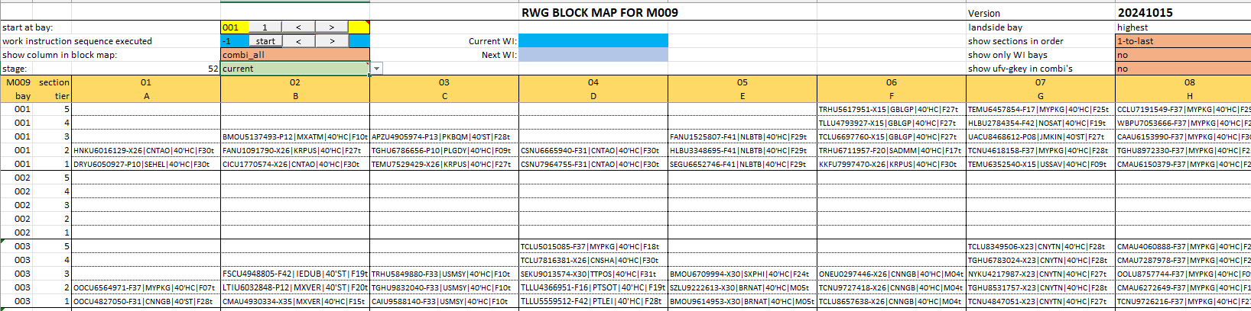
This will give you an overview of all containers in the block at the moment you loaded all data. On the left it shows the bays together with the tiers. The columns are showing the sections. Each cell shown is therefore a slot (used for 20/40/45 ft ctrs; the extended bay for 40ft ctrs are shown empty, you have to be aware yourself it is physically occupied).
The following controls and selections are possible:
Cell D2: controls the viewable part of the block; only 10 bays are shown at a time and with the buttons [<] [>] and [1] you select the viewable part.
Cell D3: controls stepping through the moves being copied into the [moves] tab. [start] brings you to the situation before the 1st move, [<] and[>] allows you to go back and forward in the move list (or use [Ctrl]-[N] or [Ctrl]-[P] for Next or Previous move). To make use of this you have to set the value in Cell D5 to future_seq. Another very handy setting is in Cell J4. Set this to fromto will switch bay 1 and bay 2 to become the from and to bays, avoiding any scrolling into the blockmap to find the from and to positions.
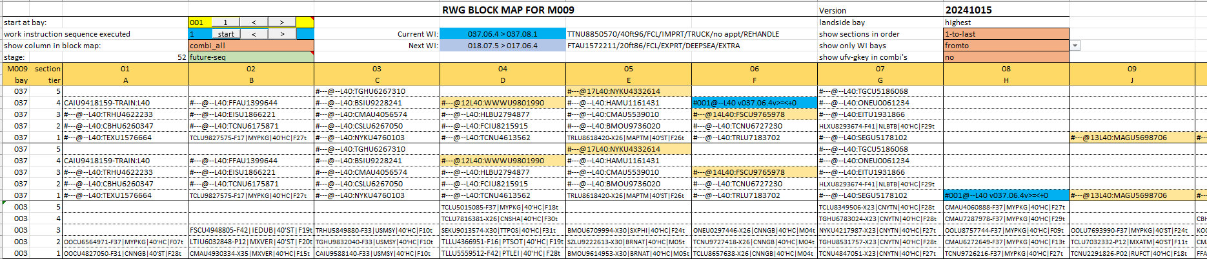
The Current Wi is shown in Cell F3 (the next in the cell below). The first bay gives a full overview of the from bay for this move, the 2nd bay shown the to-position. The container being moved is shown in the same color blue.
So when pressing the [>] in D3 will show the next move:
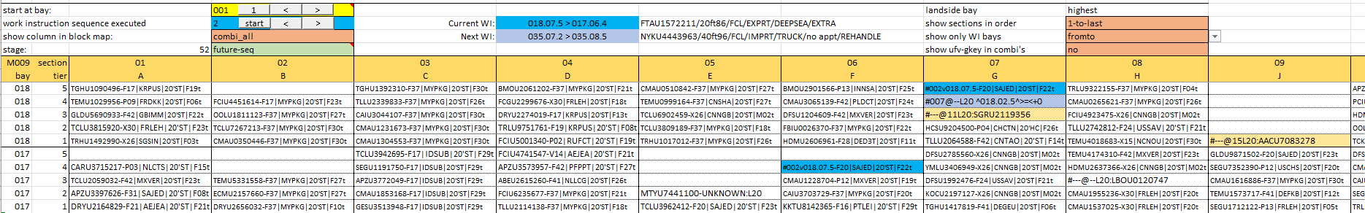

The current and next Wi are shown in the header, showing a subset of well-known fields. The last field is an explanation for that move, deducted by the excel itself.
For a static analysis (so not using the move buttons), sometimes it is handy to see the current state of the block and the future-end state of the block, when all moves has been completed as is.
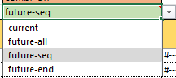

Another handy view can be the Wi-only. This condenses the block view to bays involved in a move (as the from or to-location). For the same move #2 it will look like:
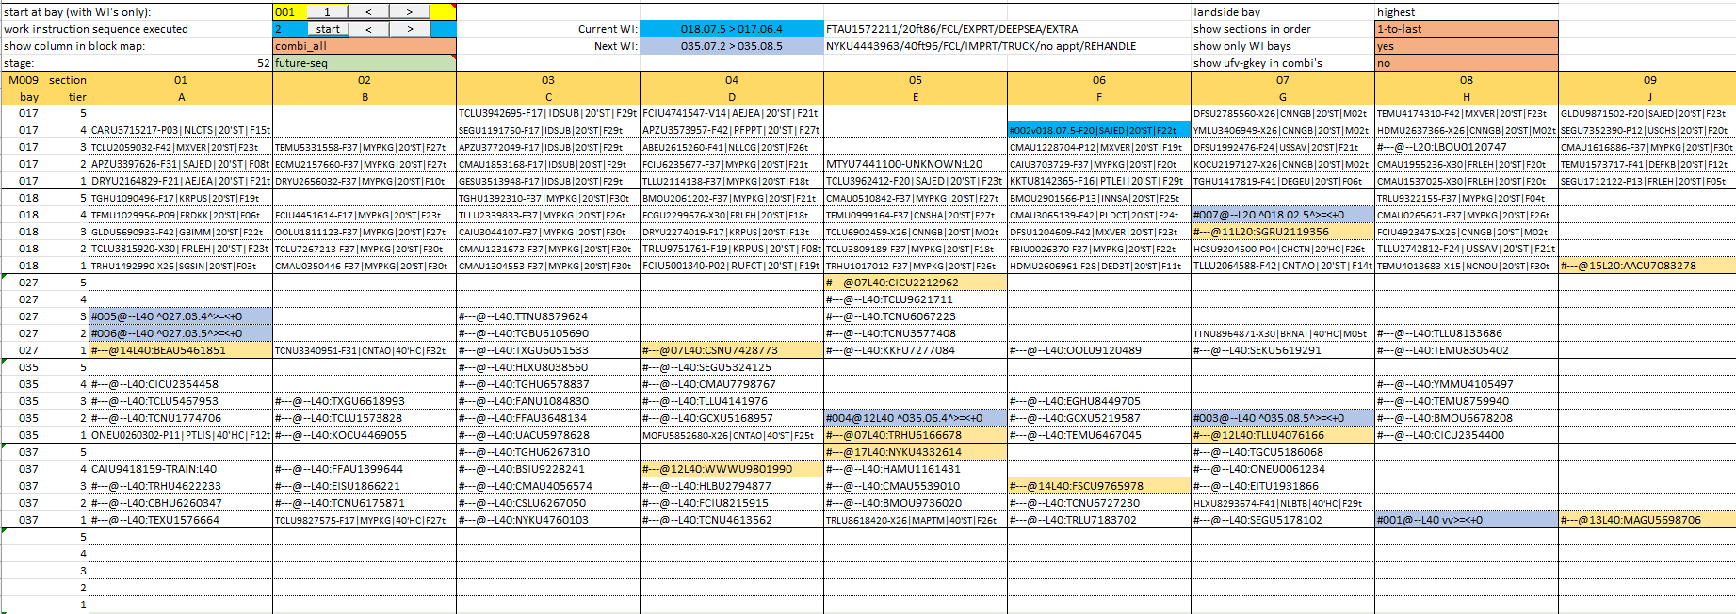
So you now have a full single page (in case there are not to many moves) overview of all from and to locations including condensed information into each cell. The information shown in each cell can also be changed using Cell D4.
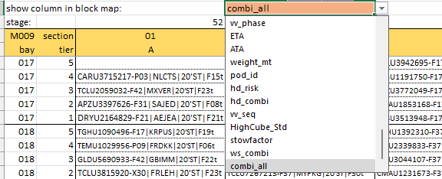
The current view uses combi_all; this is a merge of 2 other combined values, 1 for landside (ls-combi) and one for waterside (ws-combi) exit use (ls-combi when departure is truck, ws-combi will be shown when departure is via vessel).

The format of these values are:
ls-combi:
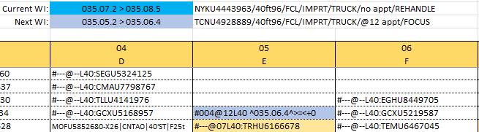
Move #4 is now shown before it gets moved; the cell value is now showing the following:
#004@12L40^035.06.4^<=<+0 means: move #4, appt @12:00 next day, Length 40, going to 035.06.4, staying in the same bay, no more moves for this ctr afterwards.
When we press [Ctrl]-[N] to go to the next move, our ctr will be moved to its destination:
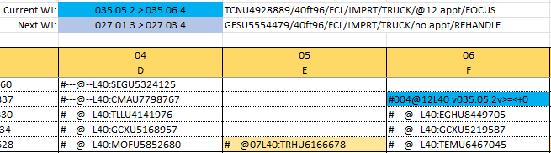
So the ctr is not showing in the from position anymore, and in the destination it shows the same info, except now it will show where it came from v035.05.2v.
The yellow value is showing an appointment ctr (@07:00) but without a move being planned.
When no appointment or move info is present for a container, it will show only Length and it’s container-id.
ws-combi:
The waterside combi cell value combines some fields relevant to assess waterside related moves. When a container has a vessel as exit carrier the following will be shown in the cell:
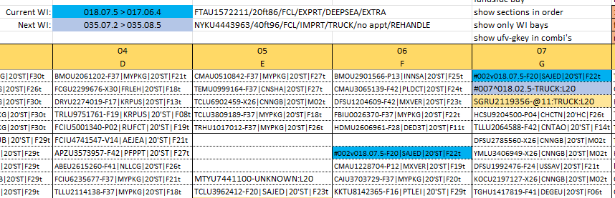
#002v018.07.5-F20|SAJED|20'ST|F22t == Move #002, from-pos = 018.07.5, Vessel-visit-idx F20 (explained later), POD = SAJED, 20ft ctr Standard Height, Full 22t weight. The Current WI above contains a bit more data like category, vessel class and move type.
Other cells for other purposes are shown as follows:

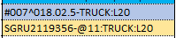

Move #007 () is a housekeeping move for a container which will exit via truck, but not for this purpose, it is a rehandle prevention for the SGRU beneath it.

The SGRU does have appointment for tomorrow 11:00, but will not be moved. The housekeeper only makes sure that it get freed from any future rehandles.

List of vessel visits found in this block:

The waterside exit move #002is referring to vessel-visit-index F20. The full list of all found vessel visits can be found in the [visits] tab starting at column K.
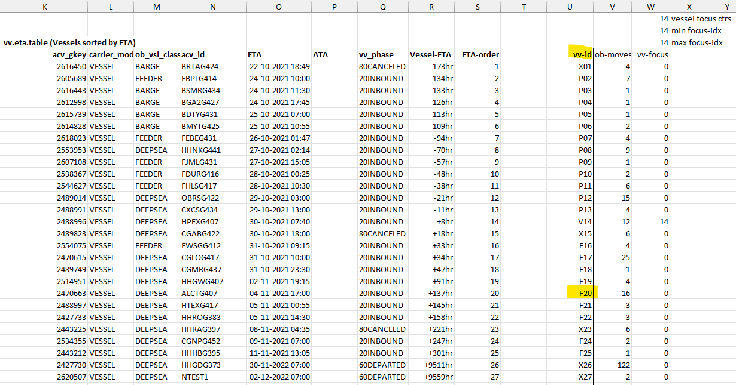

The order of the list build up based on ATA and ETA; when ATA is given this will be used, else the ETA and they are put in order of the combi of these 2.

The following prefixes are used for the found vessel visits:

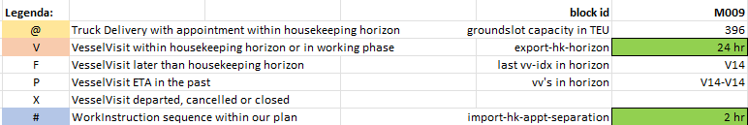

So F20 means, it is vessel visit outside our housekeeping horizon and number 20 in this list.

The only actual vessel-visit is V14, although it is still inbound, it’s ETA is within the horizon of 24 hrs, as you can see in the export-hk-horizon cell.

Note: data is based on what is found in T2, and is not representative anymore for an actual production situation.

Reporting and validation
As mentioned before, assessing a plan is not a black and white outcome, this is bad or this is good. There is more nuance to it, because there are so many constraints a plan has to take of. To get a good insight of the result of a plan, you can get a overview of the plan result in the [report] tab:
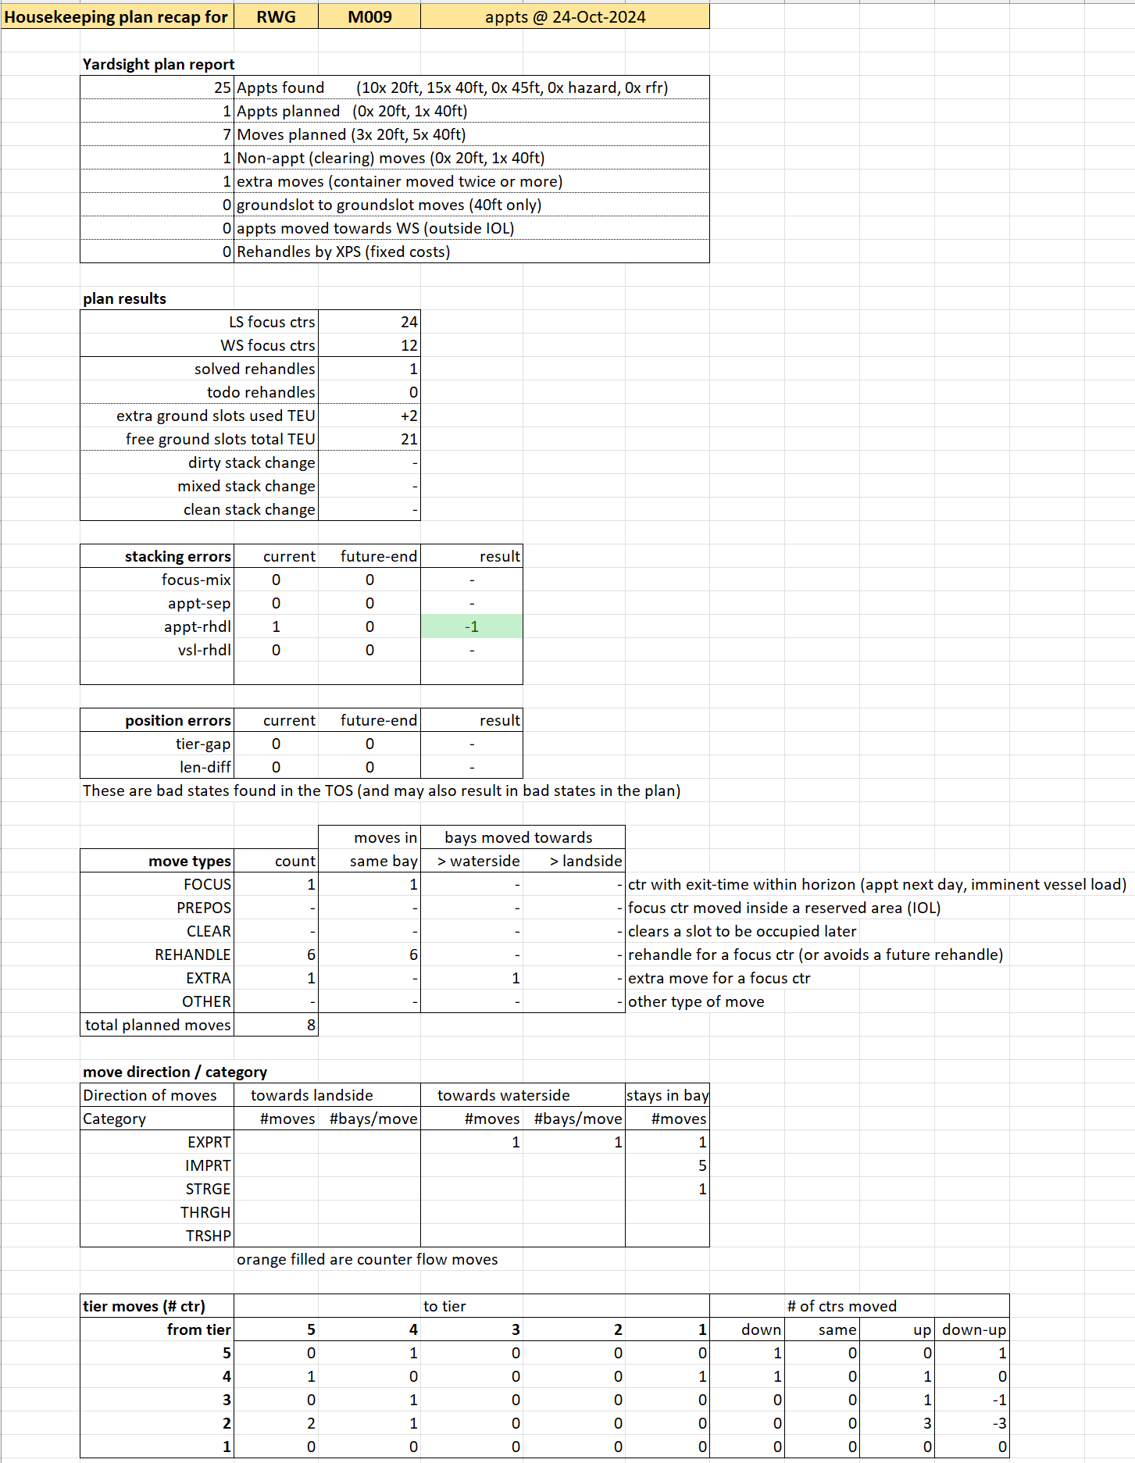
The report of the plan is mainly based on the more detailed validation you can find in the [validation] tab.
Starting at column L there is an overview of the result of a plan:
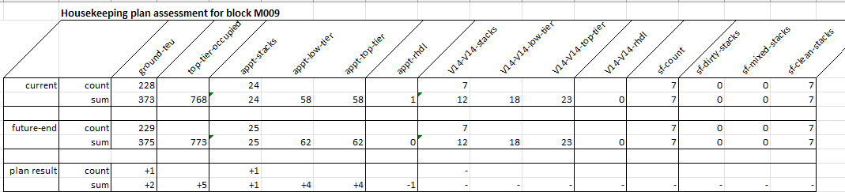
Showing the result of the moves:
- Changes in ground spots
- Stacks occupied by relevant appointment
- Amount of rehandles for appointments
- No. of stacks with vessel-visits within the horizon
- Changes in dirty/mixed/clean stacks
The count is about containers, de sum is about TEU’s
To focus on stacks affected by the plan, you can filter on column focus-stacks by filtering oput all blanks, resulting in:
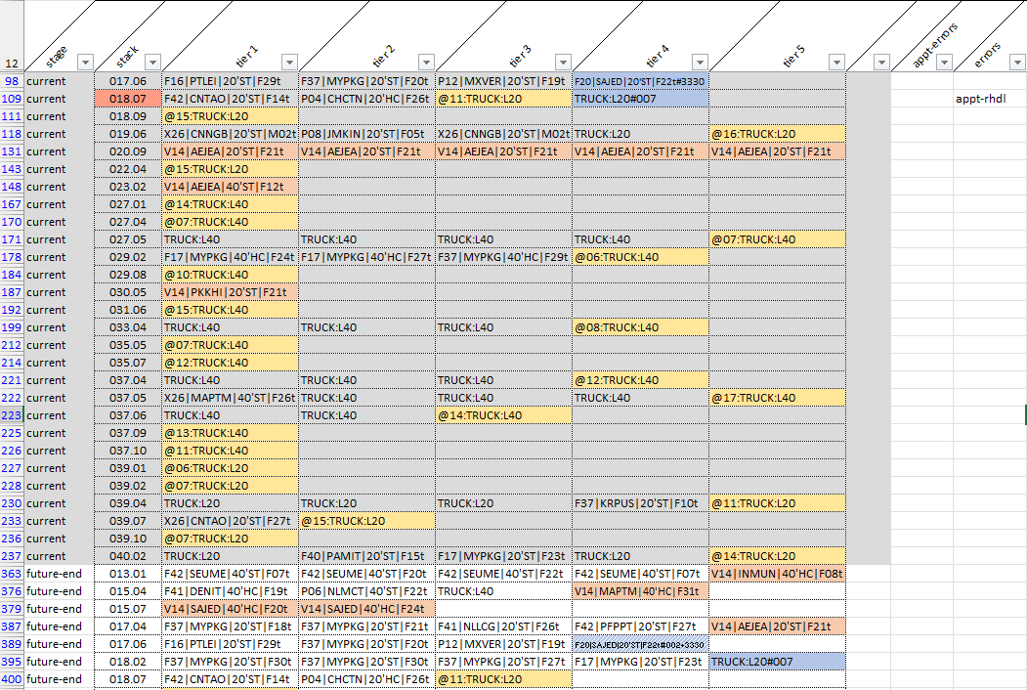
Here you see in the current state, stack 018.07 has a problem, the container in tier 4 is a future rehandle for the appointment @11:00 beneath it. And it is solved when the plan got executed (see same stack in the future-end part below it).

